**Setting nexus as a service:**

* After installing the nexus, set the NEXUS_HOME directory where we installed nexus in bash_profile

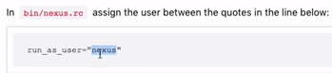

* Then in /bin/nexus.rc, enter the line with username as above

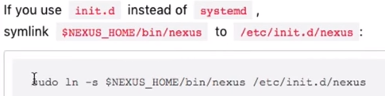

* Now execute the above command

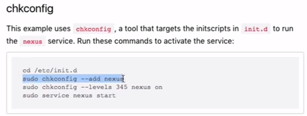

* Then after, execute the above commands as well
* After all this, we can use nexus as a service